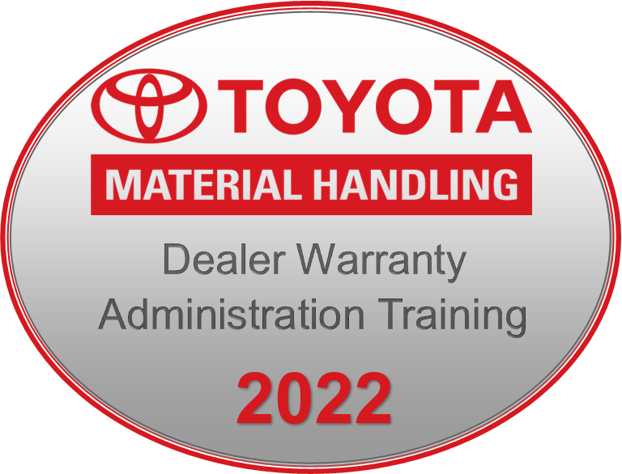

Training Hosted by the TMH Warranty Department

October 18-19, 2022

Please complete one form for each attendee.
Return to TMH no later than 10/4/2022.
Please submit via email to Warranty.Support@toyotatmh.com .

Dealership Name:

Dealership Code(s):

Attendee Name:

Attendee Title:

Attendee Phone:

Attendee Email:

BEGINNER or ADVANCED TRAINING modules:

Attendee’s Manager Name:

Attendee’s Manager Phone:

Attendee’s Manager Email:

Hotel rooms can be booked through the following link:
Book your group rate for Toyota Industries Group

